Document Release Status

**Draft**

|  |  |
| --- | --- |
| Release Date | Version |

2017-11-27 1.0

**XYP APA System Performance Requirements to EPS Module**

|  |  |  |  |  |  |
| --- | --- | --- | --- | --- | --- |
|  |  | Document Name  **XYP APA System Performance Requirements to EPS Module** | | | |
|  |  |
|  |  |  |  |  |  |
|  | | Document Type |  |  |  |
| Owner Domain: Document Prefix | | |  |
| Document No | Revision | Volume No | Page No |
|  | **1.0** |  | **1 (9)** |

Document Release Status

|  |  |
| --- | --- |
| **Draft** |  |
|  |  |
| Release Date | Version |
| 2017-11-27 | 1.0 |

**Revision history**

|  |  |  |  |  |
| --- | --- | --- | --- | --- |
| **Previous** | **Current** | **Version Description** | **Responsible** | **Date** |
| **Version** | **Version** |  |  |  |
|  |  |  |  |  |
| N/A | Draft | Specify APA performance requirement | XYP | 2017-11-9 |
|  | V1.0 | parameters to EPS for Qoros CF16 |  |  |
|  |  |  |  |  |
|  |  |  |  |  |
|  |  |  |  |  |

**Change log**

|  |  |  |
| --- | --- | --- |
| **Release** | **Section** | **Change Description** |
|  |  |  |
|  |  |  |

|  |  |  |  |  |  |
| --- | --- | --- | --- | --- | --- |
|  |  | Document Name  **XYP APA System Performance Requirements to EPS Module** | | | |
|  |  |
|  |  |  |  |  |  |
|  | | Document Type |  |  |  |
| Owner Domain: Document Prefix | | |  |
| Document No | Revision | Volume No | Page No |
|  | **1.0** |  | **2 (9)** |

Document Release Status

**Draft**

|  |  |
| --- | --- |
| Release Date | Version |

2017-11-27 1.0

**Contents**

**1 INTRODUCTION** **4**

**1.1 SCOPE OF DOCUMENT** **4**

**1.2 REFERENCE DOCUMENT** **4**

**1.3 ABBREVIATION** **4**

**2 THE STEERING ANGLE RESOLUTION AND UPDATE RATE** **5**

**3 STEERING WHEEL CONTROLLING INTERACTION BETWEEN APA AND EPS** **6**

**3.1 STEERING WHEEL CONTROLLING STRATEGY** **6**

3.1.1 STEERING WHEEL ANGLE CONTROL STEP 7

3.1.2 DEAD TIME / EPS INDIVIDUAL PROCESSING TIME 7

3.1.3 STEERING WHEEL ANGLE ACCELERATION 7

3.1.4 STEERING WHEEL ANGLE VELOCITY 8

3.1.5 STEERING WHEEL ANGLE ADJUSTED TIME 8

3.1.6 STEERING WHEEL ANGLE CONTROLLED DEVIATION 8

3.1.7 STEERING WHEEL CONTROLLED ANGLE RANGE 9

3.1.8 JUMP SIGNAL (OPTIONAL) 9

**3.2 MAXIMUM TORQUE APPLIED TO DRIVER** **9**

|  |  |  |  |  |  |
| --- | --- | --- | --- | --- | --- |
|  |  | Document Name  **XYP APA System Performance Requirements to EPS Module** | | | |
|  |  |
|  |  |  |  |  |  |
|  | | Document Type |  |  |  |
| Owner Domain: Document Prefix | | |  |
| Document No | Revision | Volume No | Page No |
|  | **1.0** |  | **3 (9)** |

、

Document Release Status

**Draft**

|  |  |
| --- | --- |
| Release Date | Version |

2017-11-27 1.0

**1** **Introduction**

**1.1** **Scope of Document**

This document specifies TTE APA system performance requirements to EPS module for Qoros CF16.

|  |  |  |  |  |  |
| --- | --- | --- | --- | --- | --- |
| **1.2** | **Reference document** | |  |  |  |
| Table 1.2.1 lists the reference documents. | | |  |  |  |
| **Table 1.2.1**: Reference | | |  |  |  |
|  |  |  |  |  |  |
| **Reference** | **Source** |  | **Title** | **Version or date** | **Document** |
| **Num** |  |  |  |  | **Number** |
|  |  |  |  |  |  |
|  |  |  |  |  |  |
|  |  |  |  |  |  |
|  |  |  |  |  |  |
|  |  |  |  |  |  |

**1.3** **Abbreviation**

.Table 1.3.1 lists the reference words.

**Table 1.3.1:** Abbreviation

|  |  |
| --- | --- |
| **Acronyms** | **Description** |
|  |  |
|  |  |
|  |  |
|  |  |
|  |  |
|  |  |
|  |  |

|  |  |  |  |  |  |
| --- | --- | --- | --- | --- | --- |
|  |  | Document Name  **XYP APA System Performance Requirements to EPS Module** | | | |
|  |  |
|  |  |  |  |  |  |
|  | | Document Type |  |  |  |
| Owner Domain: Document Prefix | | |  |
| Document No | Revision | Volume No | Page No |
|  | **1.0** |  | **4 (9)** |

Document Release Status

**Draft**

|  |  |
| --- | --- |
| Release Date | Version |

2017-11-27 1.0

**2** **The Steering Angle Resolution and Update Rate**

Semi-automatical APA system function is realized by controlling steering wheel angle. Its resolution directly affects the vehicle angle positional resolution. The steering angle resolution is lower,the deviation of vehicle final park position is greater.

The steering angle resolution must be controlled **within 0.1deg**. And in order to make sure trajectory accuracy, update rate of steering angle also should be quick engough. Its value required is **10 ms**.

Example:

|  |  |  |  |  |  |  |  |  |
| --- | --- | --- | --- | --- | --- | --- | --- | --- |
| **Message** | **Signal Name** | **Length** | **Byte** | **Unit** | **Factor** | **Offset** | **Value Range** |  |
| **(Bit)** | **Order** |  |  |  |
|  |  |  |  |  |  |  |
|  |  |  |  |  |  |  |  |  |
| APA_PDC_1 | REQ_APASWhlT | 16 | Intel | deg | 0.1 | - 800 | Min:- 800.0 |  |
|  |  |  |  |  |
| (0x131) | argetAngle |  |  | Max: 800.0 |  |
|  |  |  |  |  |  |
|  |  |  |  |  |  |  |
|  |  |  |  |  |  |  |  |  |
| EPS_2 | EPS_ActStrAngle | 15 | Intel | deg | 0.04375 | 0 | Min: 0 |  |
| (0x0F8) |  |  | Max: 1433.51 |  |
|  |  |  |  |  |  |  |
|  |  |  |  |  |  |  |  |  |
| SCM_4 | SteeringPos | 16 | Intel | deg | 0.1 | - 800 | Min:- 800.0 |  |
| (0x0F5) |  |  | Max: 800.0 |  |
|  |  |  |  |  |  |  |
|  |  |  |  |  |  |  |  |  |

|  |  |  |  |  |  |
| --- | --- | --- | --- | --- | --- |
|  |  | Document Name  **XYP APA System Performance Requirements to EPS Module** | | | |
|  |  |
|  |  |  |  |  |  |
|  | | Document Type |  |  |  |
| Owner Domain: Document Prefix | | |  |
| Document No | Revision | Volume No | Page No |
|  | **1.0** |  | **5 (9)** |

Document Release Status

**Draft**

|  |  |
| --- | --- |
| Release Date | Version |

2017-11-27 1.0

**3** **Steering Wheel Controlling Interaction between APA and EPS**

**3.1** **Steering Wheel Controlling Strategy**

After getting the right to control EPS (STAT_EPSCtrlAvailable = Active), APA module would adopt a kind of steering wheel angle guiding method to make steering wheel angle change from current angle to target angle.

For instance, please see the following graphics, **Blue line** indicates target angle (signal: REQ_APASWhl TargetAngle) and **Orange line** indicates current steering angle (signal: SteeringPos). As graphics showed, current angle is - 470°and final target angle is 400. In order to achieve target angle, first of all, APA target angle would change by step of “Steering Wheel Angle Control Step” , so APA_Angle_Target equals - 400°(SteeringPos + Steering Wheel Angle Control Step = - 470°+ 70°= - 400°). And then EPS completes individual processing and steering wheel starts to turn. As current angle increasing, target angle would increase at the same time and keep a constant difference value until reach final target angle (400°).

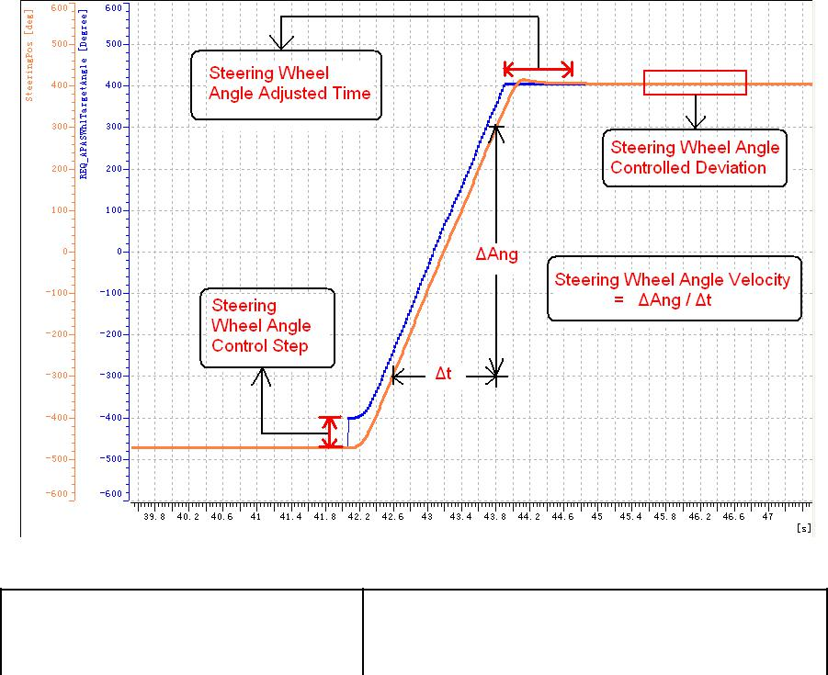

|  |  |  |  |  |  |
| --- | --- | --- | --- | --- | --- |
|  |  | Document Name  **XYP APA System Performance Requirements to EPS Module** | | | |
|  |  |
|  |  |  |  |  |  |
|  | | Document Type |  |  |  |
| Owner Domain: Document Prefix | | |  |
| Document No | Revision | Volume No | Page No |
|  | **1.0** |  | **6(9)** |

Document Release Status

**Draft**

|  |  |
| --- | --- |
| Release Date | Version |

2017-11-27 1.0

**3.1.1** **Steering Wheel Angle Control Step**

Steering wheel angle control step is used to keep the difference value between cureent angle and target angle to guide steering wheel to turn. And the requirement is that when detecting the difference value between cureent angle and target angle is great than V, the steering actuator(EPS) shoud be able to turn in its physical angle velocity (maximum steering wheel angle velocity). If steering actuator can turn in its physical angle velocity under V, it is also OK for APA system.

What’s more, the value of V should be **less than** **90 deg** and in order to make target angle curve more smooth, we hope its value can be **less than or equal to** **50 deg**.

**3.1.2** **Dead Time / EPS individual processing time**

The computing time inside the EPS shall **not take longer than** **70 ms** (i.e. it shall not take longer than 70 ms from receiving the desired road wheel angle from the APA module until full power is applied on the actuators).

**3.1.3** **Steering Wheel Angle Acceleration**

Steering wheel angle acceleration is the decisive factor for the time changing steering wheel angle velocity from 0 to physical angle velocity (maximum steering wheel angle velocity). And this value should be **great than or equal to** **1200 deg /** **s2**.

|  |  |  |  |  |  |
| --- | --- | --- | --- | --- | --- |
|  |  | Document Name  **XYP APA System Performance Requirements to EPS Module** | | | |
|  |  |
|  |  |  |  |  |  |
|  | | Document Type |  |  |  |
| Owner Domain: Document Prefix | | |  |
| Document No | Revision | Volume No | Page No |
|  | **1.0** |  | **7 (9)** |

Document Release Status

**Draft**

|  |  |
| --- | --- |
| Release Date | Version |

2017-11-27 1.0

**3.1.4** **Steering Wheel Angle Velocity**

For steering wheel angle velocity or angle acceleration, if they are not big enough or EPS’s dead time is rather big, then in the process of automatic parking , EPS can’t quickly control steering wheel turn to the desired angle, which will make parking trajectory deviate from desired trajectory. As a consequence, automatical parking performance is not ideal.

Therefore, whether the vehicle is moving or standstill, physical steering wheel angle velocity should be **great than or equal to** **450 deg / s** and it would be better if its value can be close to 500 deg / s. For the sake of function safty, we suggest the maximum steering wheel angle velocity shall **not exceed** **500** **deg / s**.

**3.1.5** **Steering Wheel Angle Adjusted Time**

This time is measured from target angle stability to current angle stability. EPS is permitted to adjust steering wheel angle to meet steering wheel angle controlled deviation, but it should be completed within maximum steering wheel angle adjusted time, which is **1 s**.

What’s more, the fluctuation angle should be controlled **within** **20 deg** ( |current angle – stable target angle | <= 20 deg).

**3.1.6** **Steering Wheel Angle Controlled Deviation**

This is the absolute difference value between current angle and target angle when target angle is stable (Steering Wheel Angle Controlled Deviation = | SteeringPos - REQ_APASWhl Target Angle |). It should be **less than or equal to** **1°**.

|  |  |  |  |  |  |
| --- | --- | --- | --- | --- | --- |
|  |  | Document Name  **XYP APA System Performance Requirements to EPS Module** | | | |
|  |  |
|  |  |  |  |  |  |
|  | | Document Type |  |  |  |
| Owner Domain: Document Prefix | | |  |
| Document No | Revision | Volume No | Page No |
|  | **1.0** |  | **8 (9)** |

Document Release Status

**Draft**

|  |  |
| --- | --- |
| Release Date | Version |

2017-11-27 1.0

**3.1.7** **Steering Wheel Controlled Angle Range**

In normal situation, the maximum target angle sent by APA would be 90% ~ 95% of maximum physical steering wheel. But if vehicle’s minimum turning radius can not meet requirement, this percentage may be great than 95%. Therefore, the maximum steering wheel controlled angle should be **great than or equal to 95%** of maximum physical steering wheel.

**3.1.8** **Jump signal (Optional)**

When APA request EPS to turn to the target angle, the angle requested by APA gradually increases by a certain step every time. The steering wheel angle requested by APA via CAN will increase a corresponding step in each sending cycle, meanwhile make sure that the angle difference between this cycle request and last cycle must not over AngMAX and the angle difference between this cycle request and the current angle returned from EPS must not over AngMAX. When APA request angle changes frequently, EPS shall exit from Active state and enter Permanently Failed state, and will not recover until power is off and on again.

At present, TTE defined the jump signal to be **90deg**, when EPS receives **3 continous** jump signal which is **over** **90deg**, EPS should exit from Active state.

**3.2** **Maximum Torque Applied to Driver**

The EPS must indicate when the driver tries to control the steering wheel. An intervention of the driver at the steering wheel during active steering control shall be recognized by the steering actuator. If the driver interferes with the steering wheel during control, the torque applied to driver is **above** **3 Nm** for **50 ms**, the EPS shall send bus message back to the APA module to cancel the parking maneuver.

|  |  |  |  |  |  |
| --- | --- | --- | --- | --- | --- |
|  |  | Document Name  **XYP APA System Performance Requirements to EPS Module** | | | |
|  |  |
|  |  |  |  |  |  |
|  | | Document Type |  |  |  |
| Owner Domain: Document Prefix | | |  |
| Document No | Revision | Volume No | Page No |
|  | **1.0** |  | **9 (9)** |